| Course Name | ITD 2313 – Script Programming |
| --- | --- |
| Instructor | Mark Pranger |
| Student Name | Weston Albright |
| Due date | 07/15/2025 |
| Grade | 95.78% |
| Grading Comments | N/A |

**Page 147**

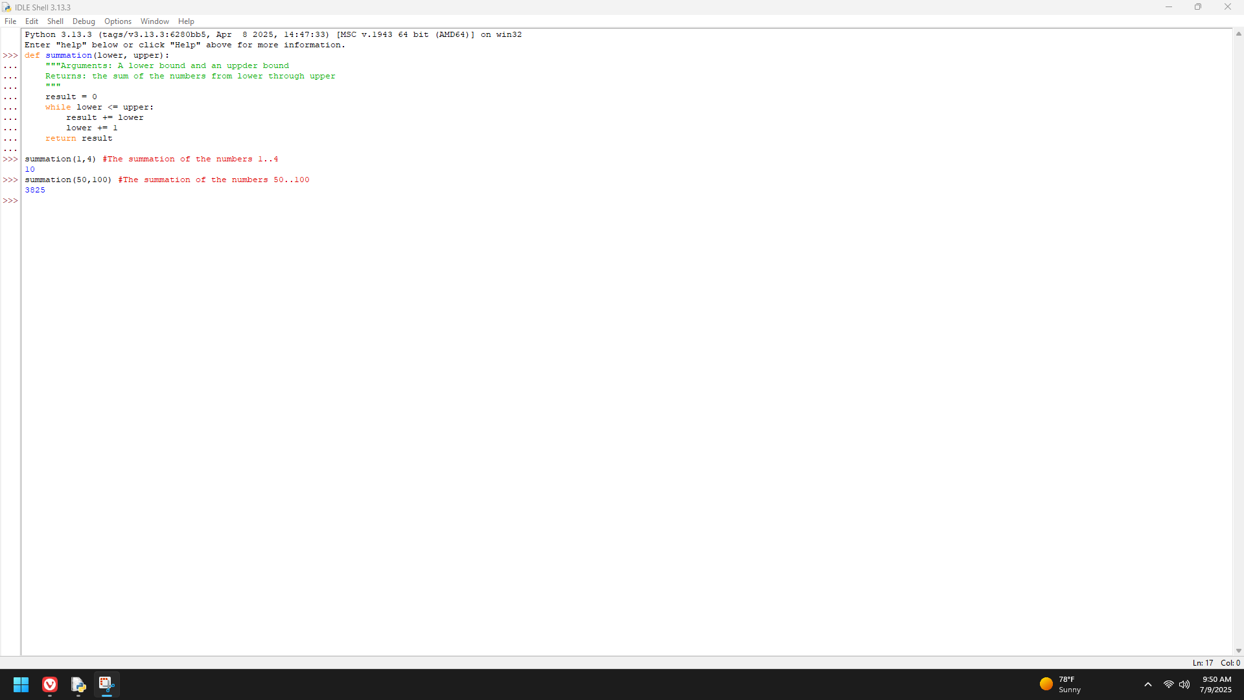

**Page 156**

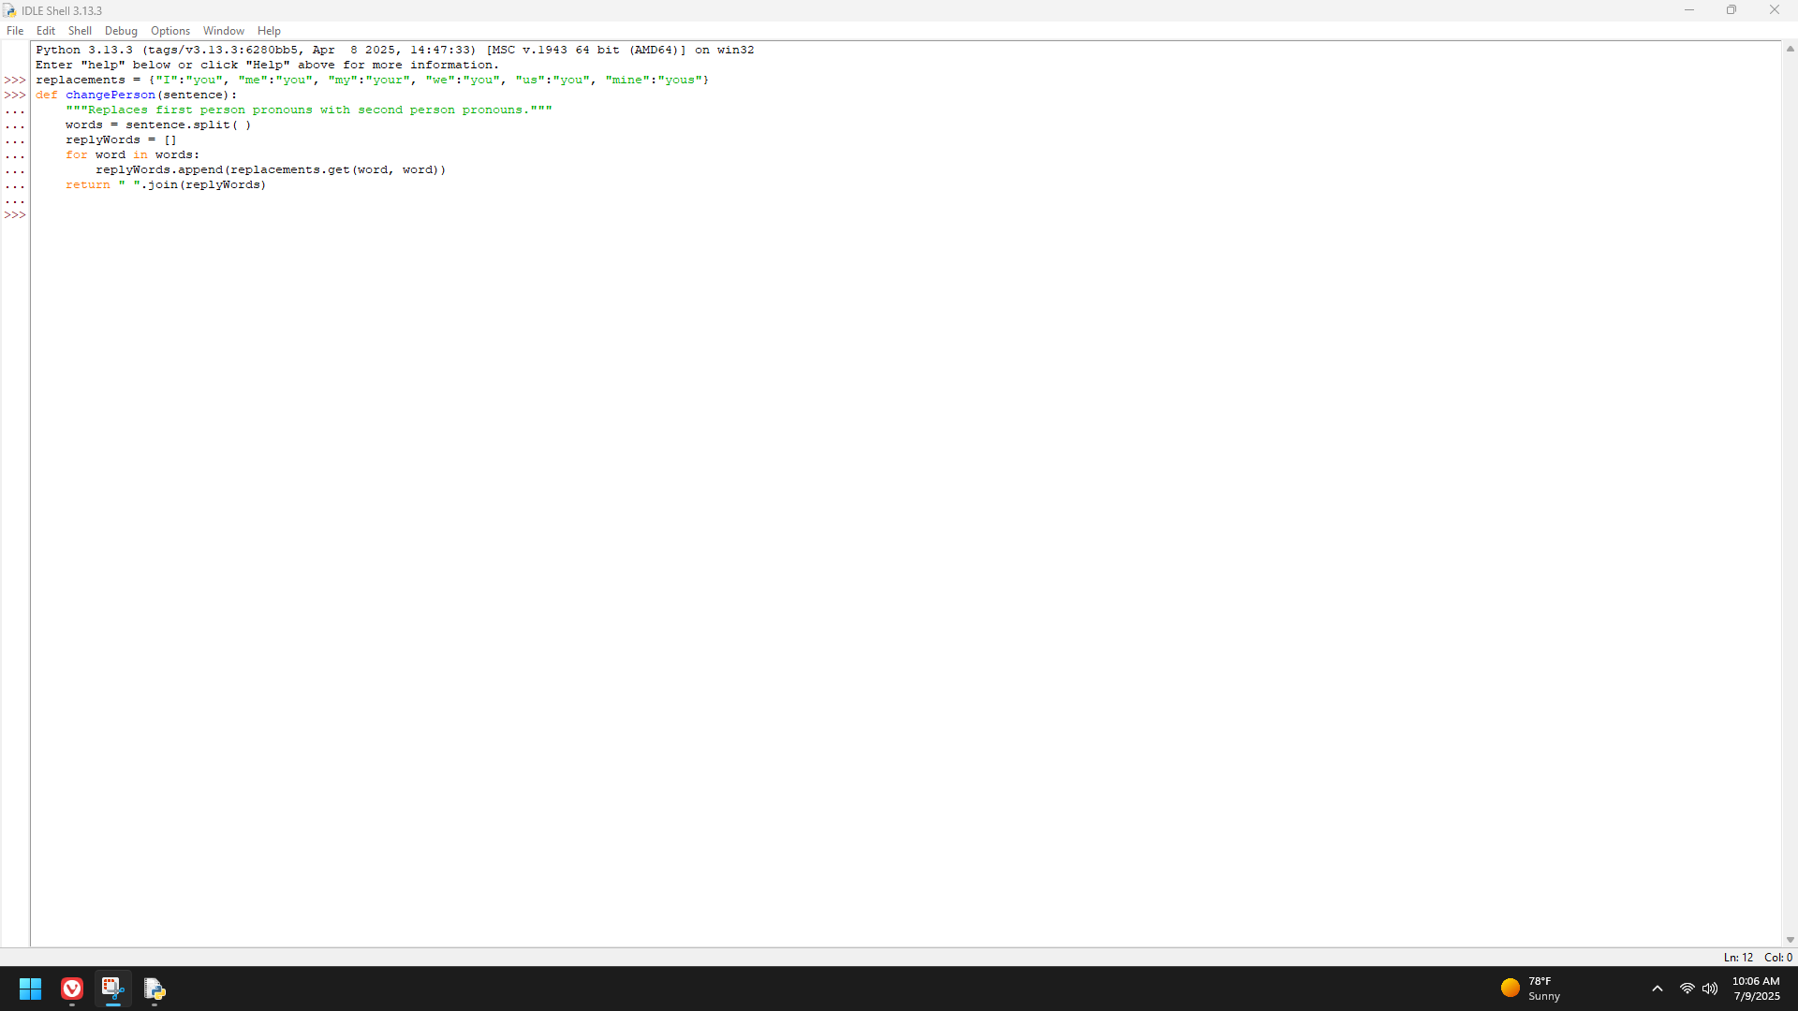

**Page 157**

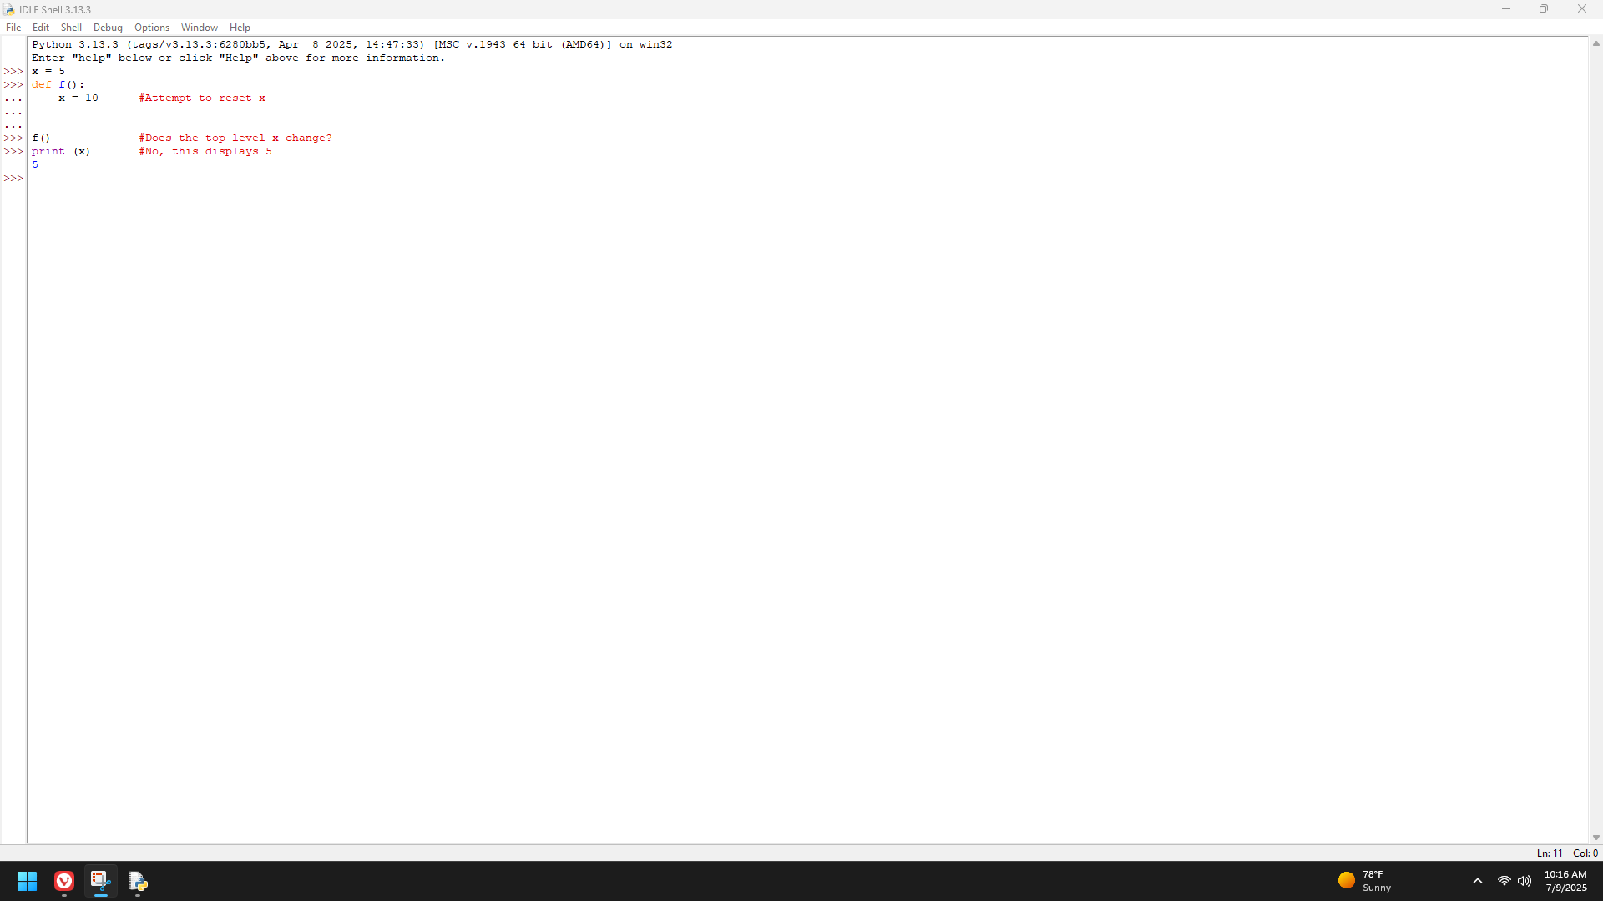

**Page 158-159**

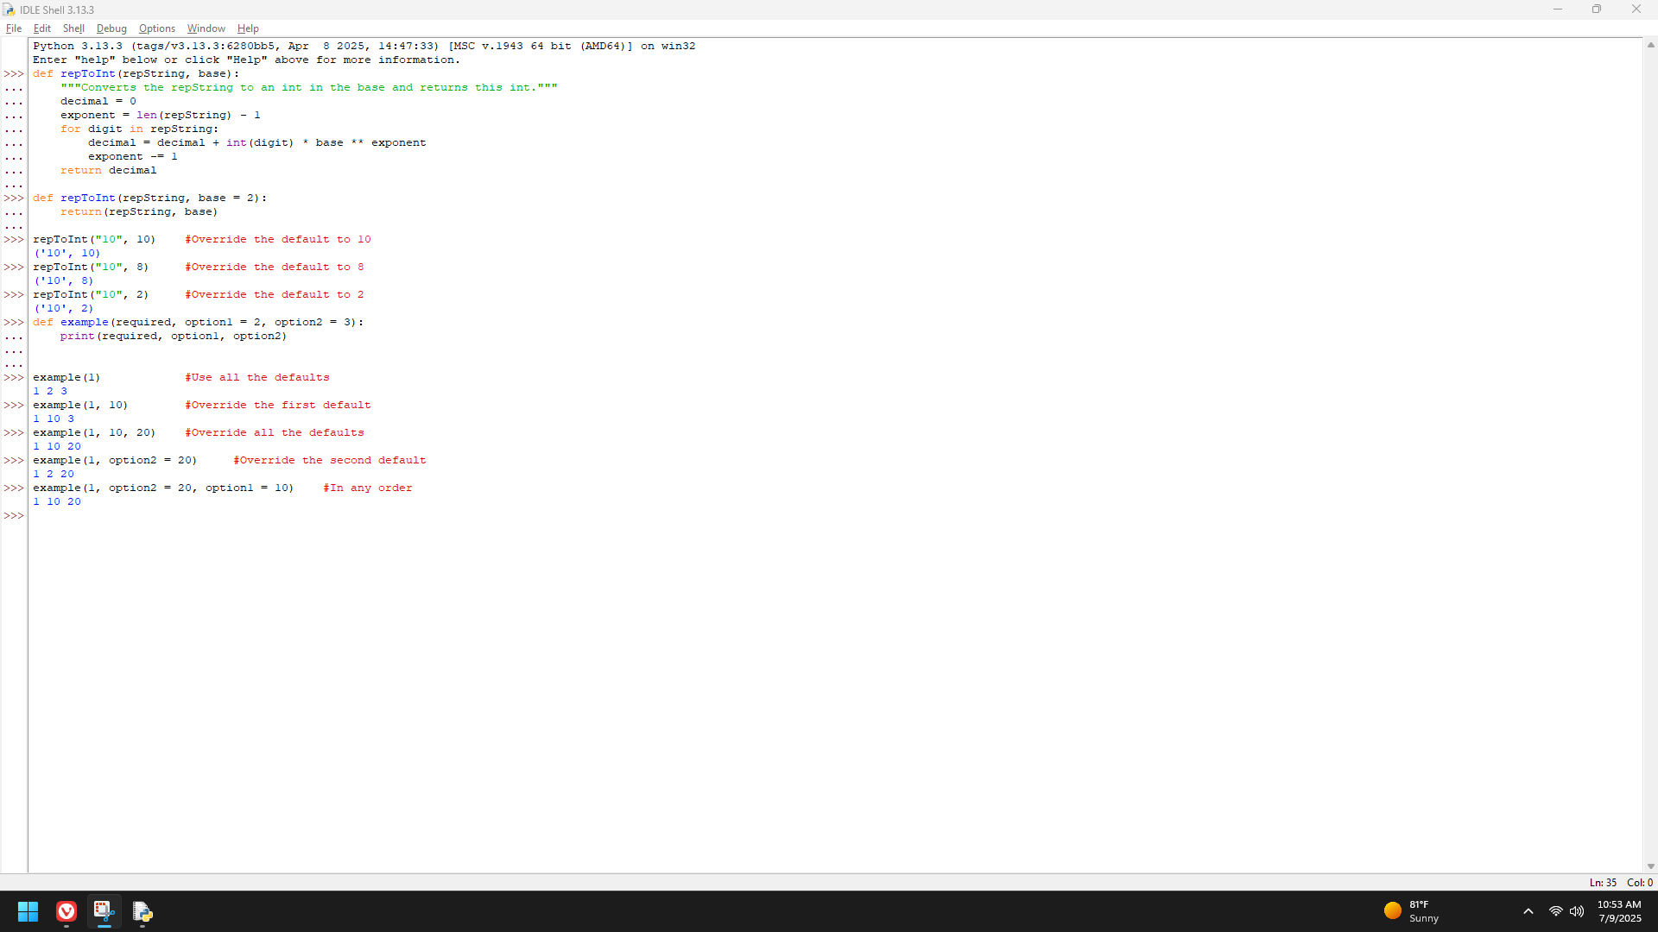

**Page 166**

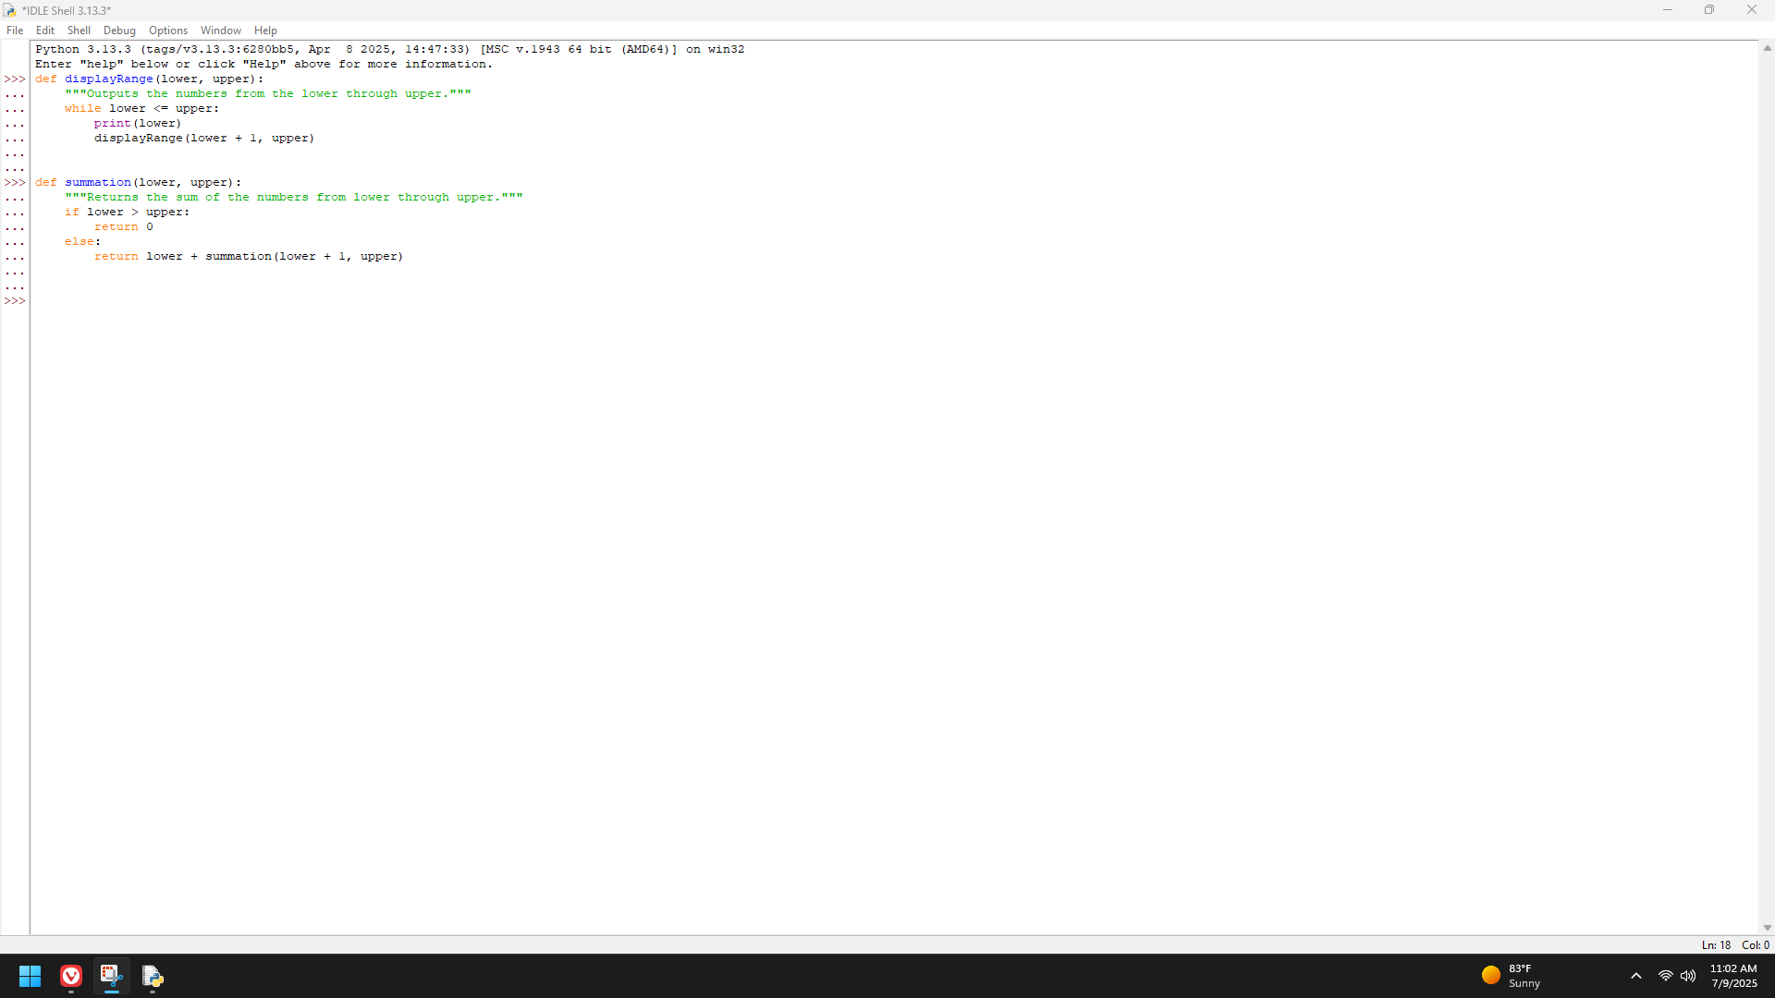

**Page 167**

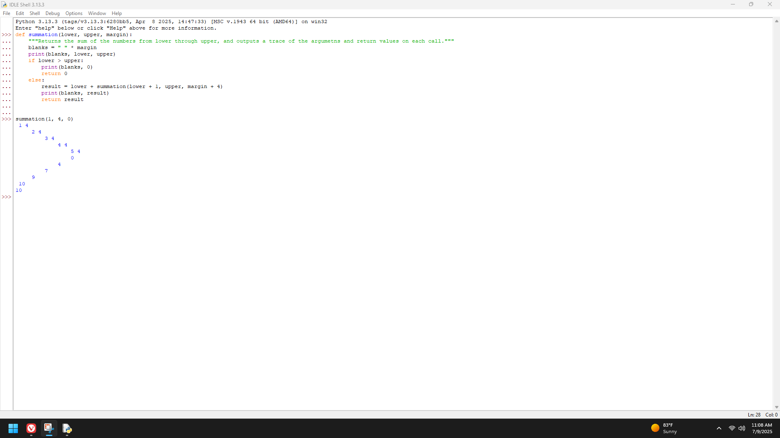

**Page 168-169**

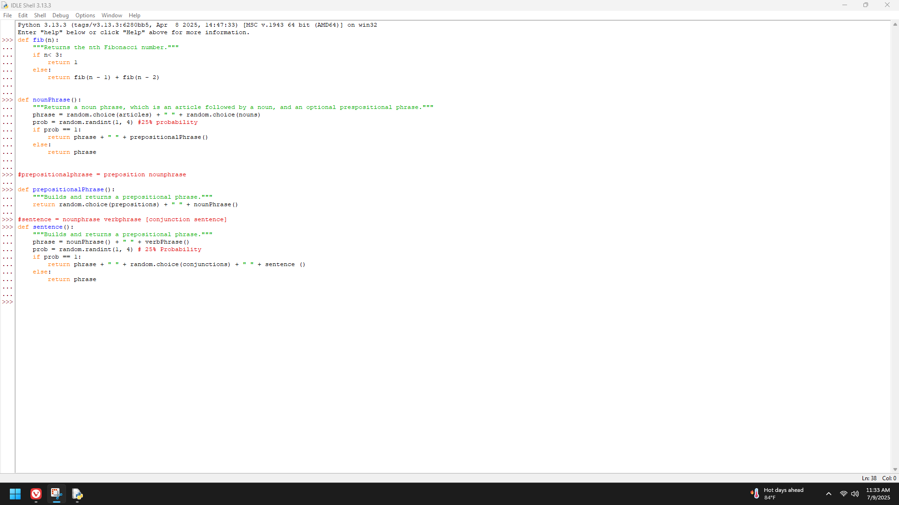

**Page 170**

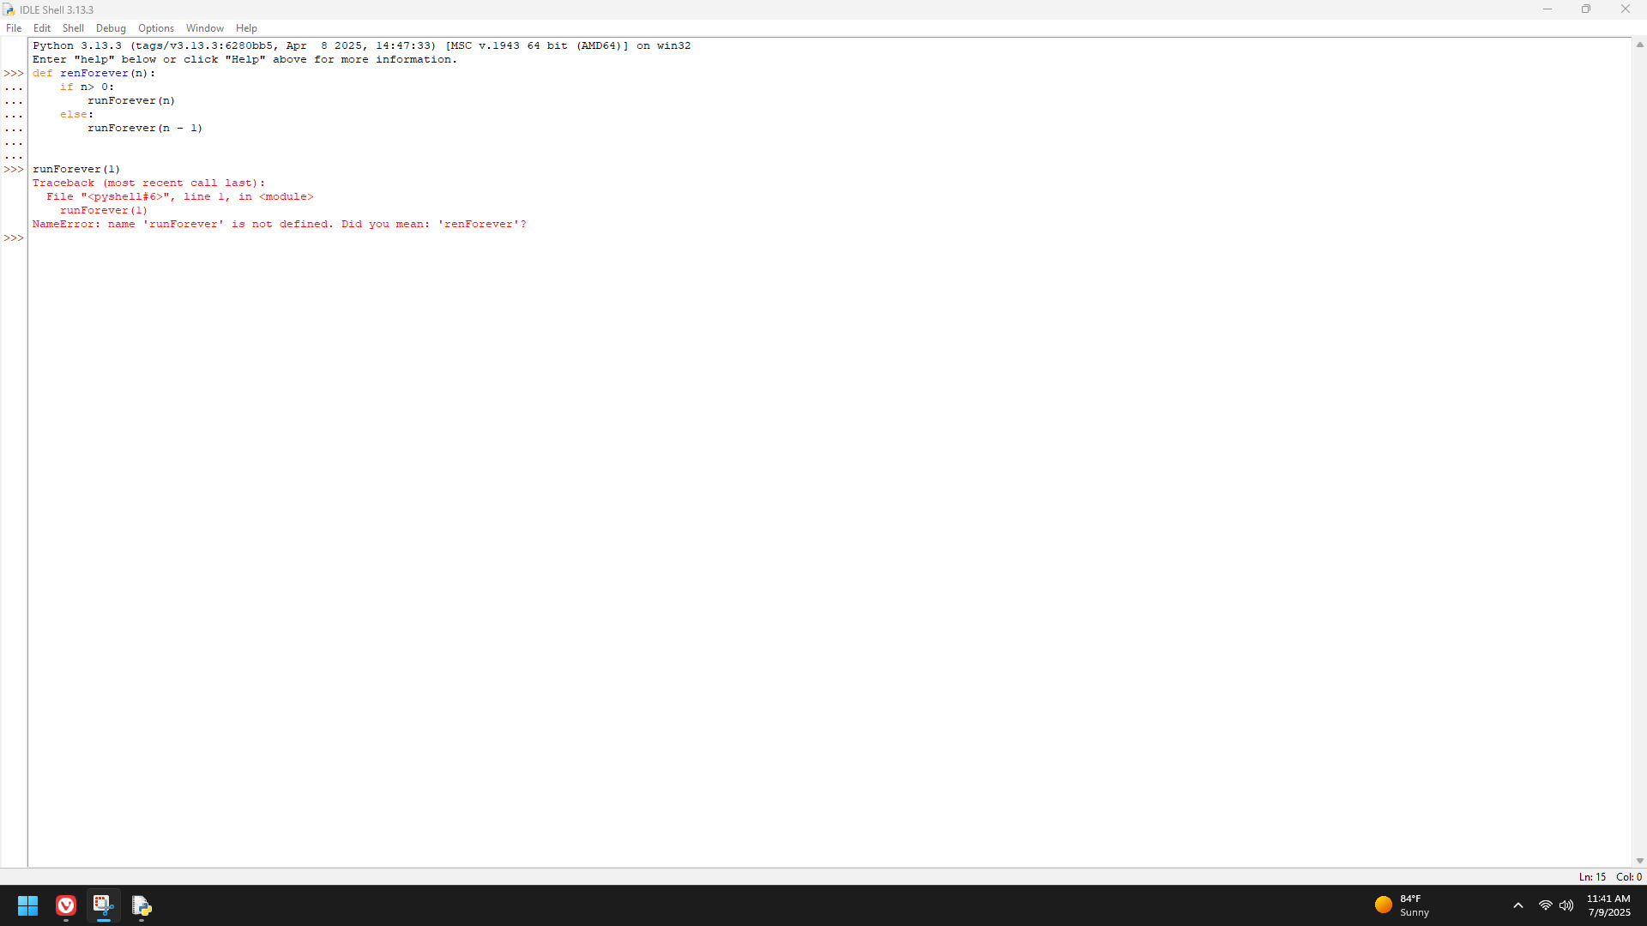

**Page 179**

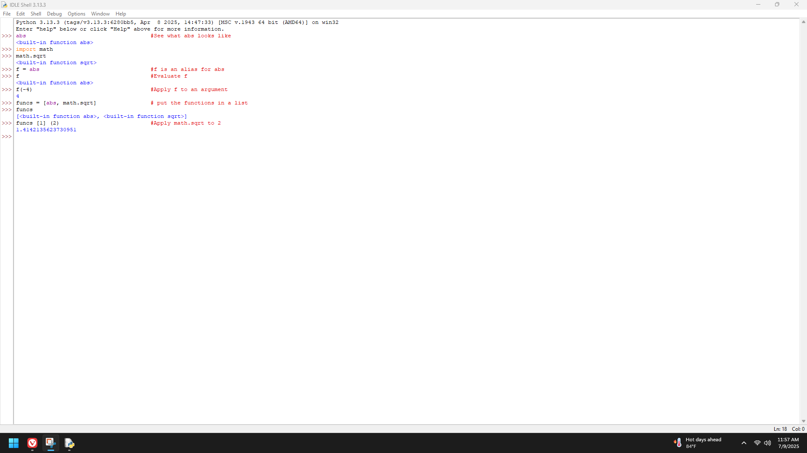

**Page 180**

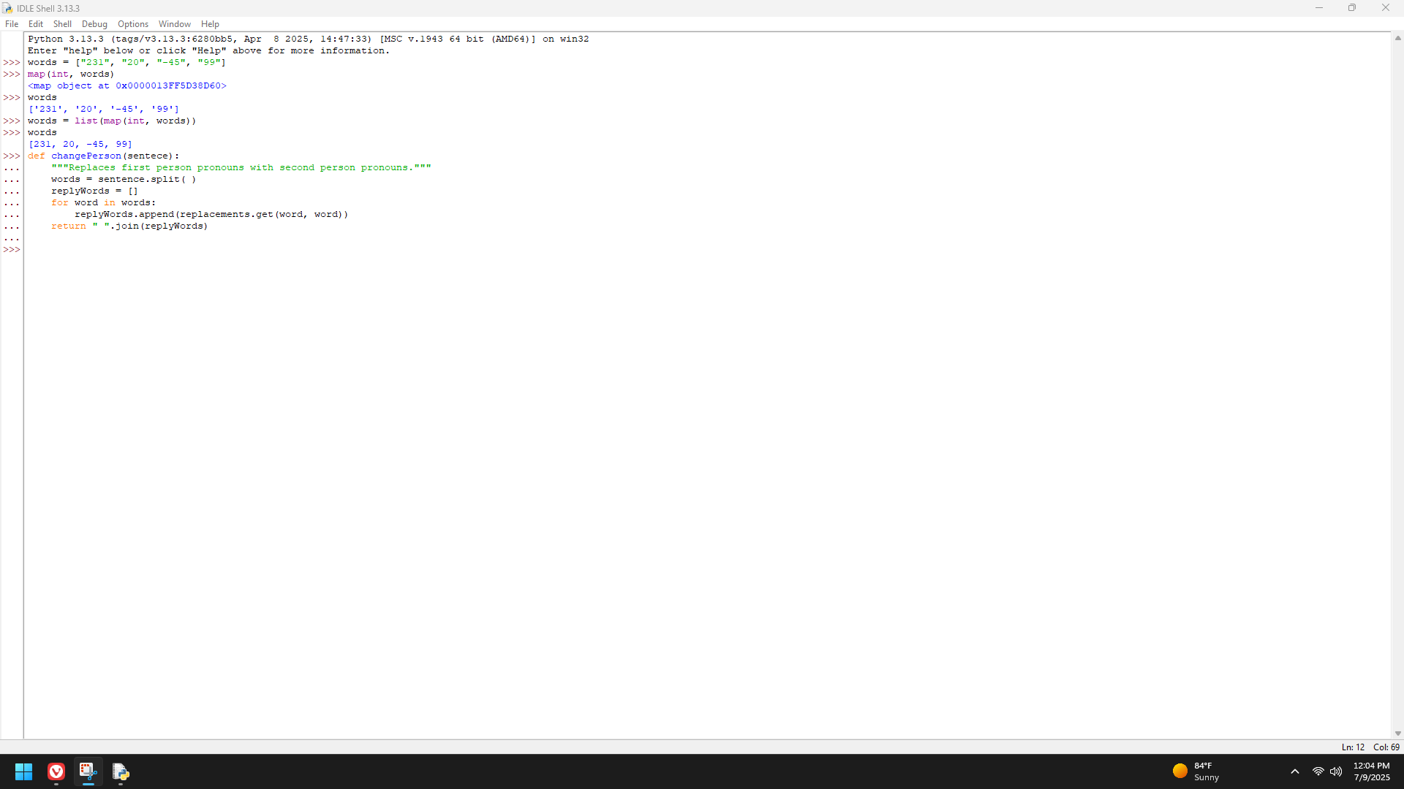

**Page 181 (Filtering)**

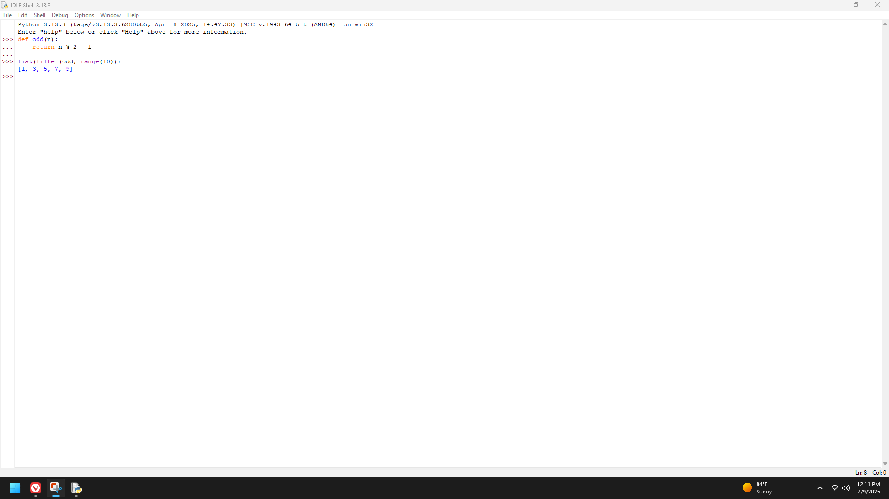

**Page 181-182 (Reducing)**

